INF 1103 Lab 5 Submission:
1: Python file (inventory_manager.py) ✅
2: Updated inventory.json file✅
3: Git Log ✅
4: Docker Mount and Run:
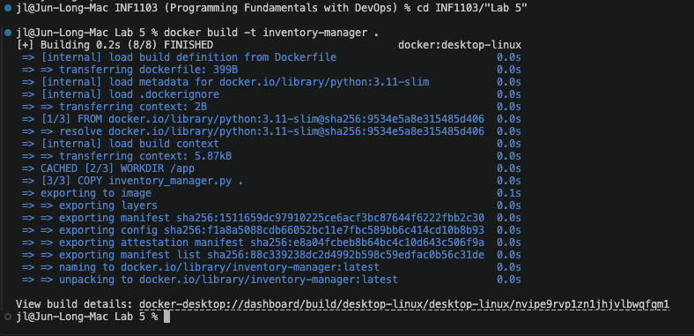
5: Evidence of image successfully built:
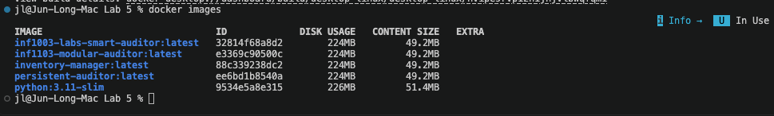
6: Proof of my invemtory_manager.py run successfully by accepting input and producing results.
